**PERFORMANCE ANALYSIS POLARIZATION RECONFIGURABLE CIRCULAR PATCH BY COMPARING AXIAL RATIO FOR DIFFERENT POLARIZATION STATES**

**(SSE-21/12/256/4)-**

**PICO:**

**Problem:** Less axial ratio bandwidth

**Intervention:** Surface current distribution orientation

**Comparison:** Axial ratio of with and without slot

**Outcome:** Frequency vs Axial ratio (with and without slot)

**INTRODUCTION:**



**MATERIALS AND METHODS**





**Data Collection: with and without slot**

|  |  |  |  |  |  |  |
| --- | --- | --- | --- | --- | --- | --- |
| S.NO | GROUP1 | FREQUENCY | AXIALRATIO  WITHSLOT | GROUP2 | FREQUENCY | AXIALRATIO  WITHOUTSLOT |
| 1 | 1 | 2.25 | 36.06 | 2 | 2.25 | 57.37 |
| 2 | 1 | 2.30 | 30.20 | 2 | 2.30 | 31.90 |
| 3 | 1 | 2.35 | 21.80 | 2 | 2.35 | 14.83 |
| 4 | 1 | 2.40 | 14.83 | 2 | 2.40 | 5.46 |
| 5 | 1 | 2.45 | 21.16 | 2 | 2.45 | 2.56 |
| 6 | 1 | 2.50 | 28.77 | 2 | 2.50 | 5.25 |
| 7 | 1 | 2.55 | 34.14 | 2 | 2.55 | 11.68 |
| 8 | 1 | 2.60 | 38.01 | 2 | 2.60 | 20.75 |
| 9 | 1 | 2.65 | 40.94 | 2 | 2.65 | 31.62 |
| 10 | 1 | 2.70 | 43.21 | 2 | 2.70 | 43.62 |
| 11 | 1 | 2.75 | 44.99 | 2 | 2.75 | 56.26 |
| 12 | 1 | 2.80 | 46.36 | 2 | 2.80 | 69.22 |
| 13 | 1 | 2.85 | 47.39 | 2 | 2.85 | 82.28 |
| 14 | 1 | 2.90 | 48.11 | 2 | 2.90 | 95.32 |
| 15 | 1 | 2.95 | 48.54 | 2 | 2.95 | 108.29 |
| 16 | 1 | 3.00 | 48.70 | 2 | 3.00 | 121.21 |

**Tables and graphs:**

|  |  |  |  |  |  |
| --- | --- | --- | --- | --- | --- |
|  | group | N | Mean | Std. Deviation | Std. Error Mean |
| frequncy | withoutslot | 16 | 2.6250 | .23805 | .05951 |
| withslot | 16 | 2.6250 | .23805 | .05951 |
| axialratio | withoutslot | 16 | 37.0751 | 10.96832 | 2.74208 |
| withslot | 16 | 47.3525 | 38.66077 | 9.66519 |

**Independent Samples Test:**

|  |  |  |  |  |  |  |  |  |  |
| --- | --- | --- | --- | --- | --- | --- | --- | --- | --- |
|  | | Levene's Test for Equality of Variances | | | | | t-test for Equality of Means | | |
| F | | Sig. | | | t | | df |
|
| Equal variances assumed | .000 | | 1.000 | | .000 | 30 | |
| Equal variances not assumed |  | |  | | .000 | 30.000 | |
| Equal variances assumed | 20.899 | | .000 | | -1.023 | 30 | |
| Equal variances not assumed |  | |  | | -1.023 | 17.399 | |

Comparison of axial ratio of with and without slot by varying the frequency ranging from 1GHz to 3GHz.there is statistically significant difference in axial ratio of with and without slot. The axial ratio of without slot is higher when compare to with slot.

**Bar Chart Comparitive Means:**

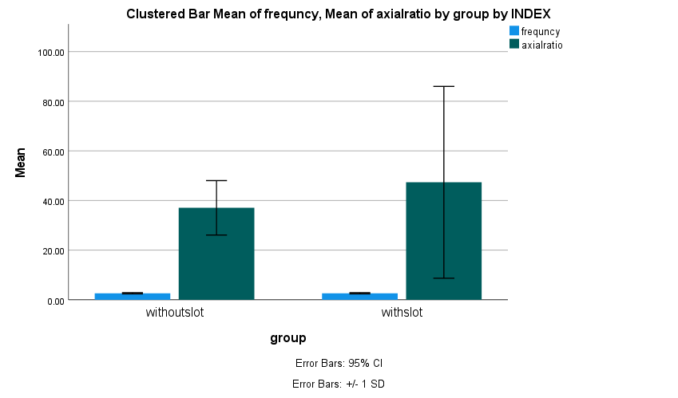

Fig. Bar chart comparing the mean axial ratio of with and without slot by varying the frequency. There is no significance difference between the two groups p>1.00(Independent sample t test).

**Results and discussion:**

**WITHOUTSLOT AXIAL RATIO:**

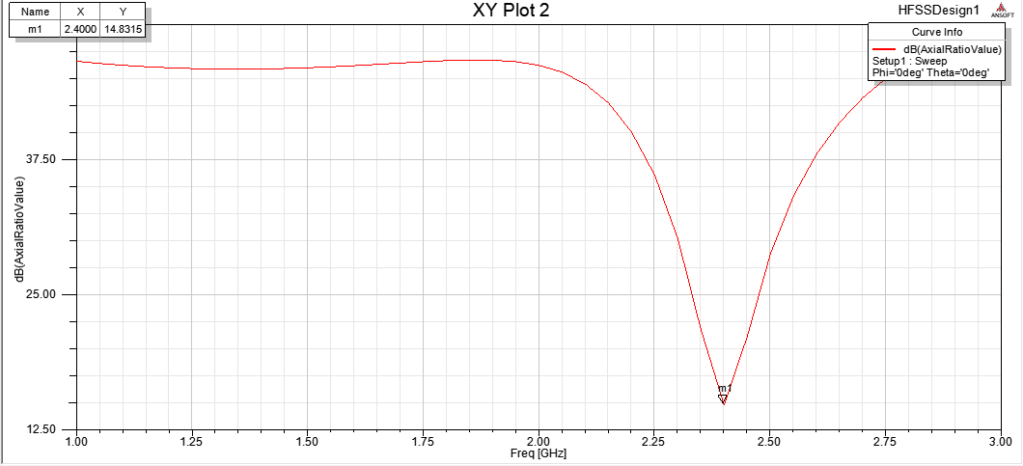

Frequency at 2.4GHz and axial ratio without slot = 14.8315

**WITHSLOT AXIAL RATIO:**

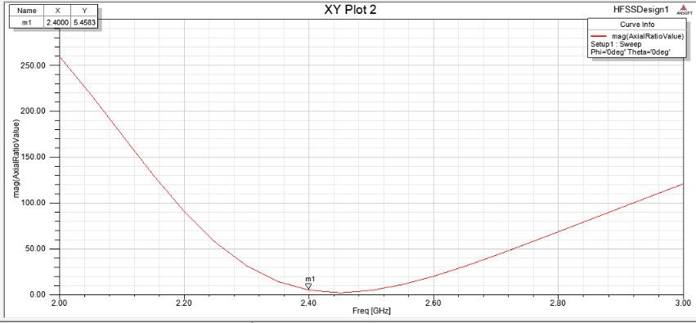

Frequency at 2.4GHz and axial ratio without slot = 5.4583

**DISCUSSION HINTS**



